ZEPHYR WEBSITE DESIGN

### PROJECT: WEBSITE THAT OFFERS WEB DESIGN AND DEVELOPMENT SERVICES

### WEBSITE NAME: ZEPHYR

### AUTHOR: EMMANUEL MUNYITE

### CANVA DESIGN: <https://bit.ly/3J9IBjA>

### GITHUB REPO: <https://github.com/munyite001/Zephyr-Web-design-and-development>

## PROJECT DEFINITION

## The project, is going to be a website that is going to be offering web design, and web development services to clients. It is going to have six modules i.e.:

* Home section
* About Us section
* Services section
* Our Team Section
* Contact section
* FAQ section

## DEVELOPMENT PROCESS

To build out the project, the first thing will be designing the layout/the user interface of the project i.e., how the website will look like to the end user.

For this process, we’ll be using [Canva](https://www.canva.com/), to build out the design of the website.

## ZEPHYR DESIGN

We’ll build out the design for each module, starting from the home module, to the last module which is the Frequently asked Questions (FAQ) module.

#### HOME MODULE

The home module, will have the navigation bar, which will have the site logo and the navigation links to join all modules. The navbar will be fixed at the top, to allow for easy navigation from one module to another.

Another feature for the home module, will be the intro section, which will span the entire background and will have a video playing in the background, with bold text, detailing the intro section

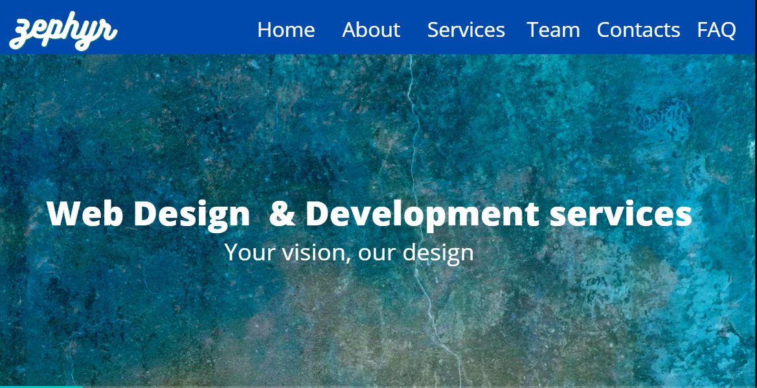

#### ABOUT US MODULE

The about us module, will have some text, giving a description of the company, zephyr, why the client should partner with us, a description of our team and the skills they offer.

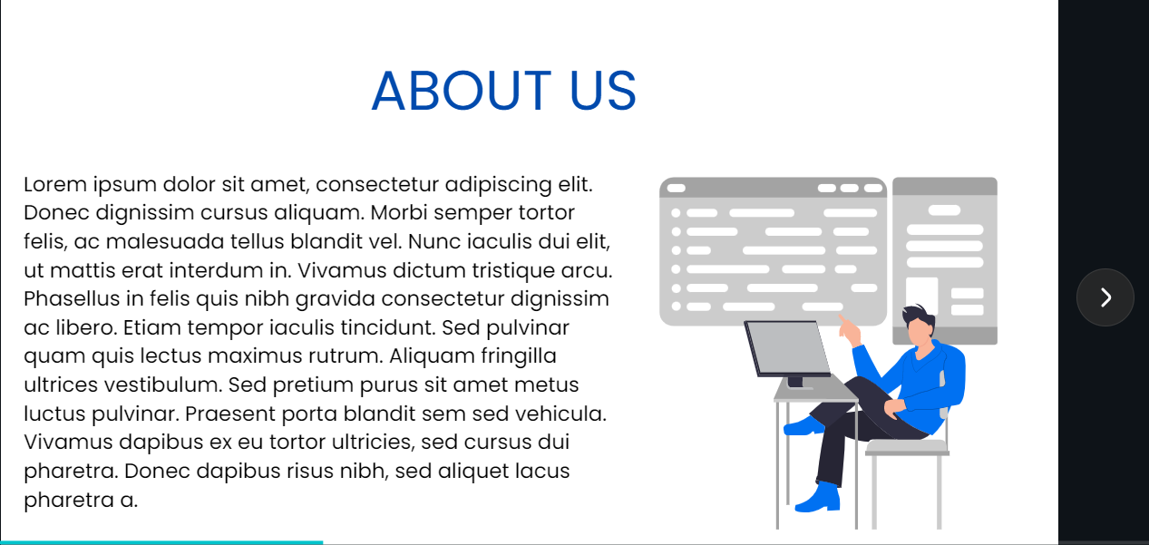

#### SERVICES SECTION

This module, will showcase, all the services that will be offered in our website., we will have row like containers positioned as rows, with two columns, one column will be the paragraph describing the service, and on the other column, an appropriate SVG illustration to give a better description of what the service does.

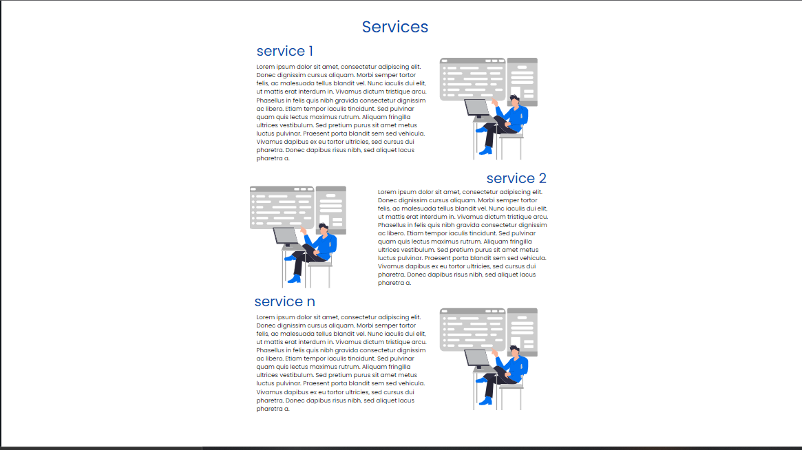

#### TEAM MODULE

For the team module, we will have a section, with card components, showcasing some of the top members of our teams and their roles e.g., web designer or web developer.

Each card component, will have a rounded image of the team member’s profile picture , their name and their role.

We will also use social media icons, that will later configure to link to each individual team member’s social profiles.

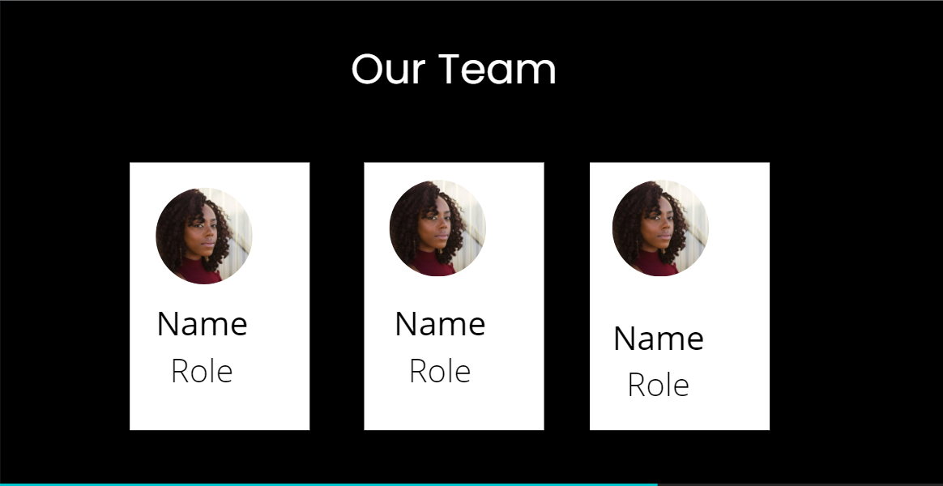

#### CONTACT US MODULE

The contact us module, will have a form where, the user can contact us, either to request for clarification, or to request for quotes on building their website.

We will have a div spanning the entire viewport, and within the div we will have two columns, one for the form and one for the SVG illustration.

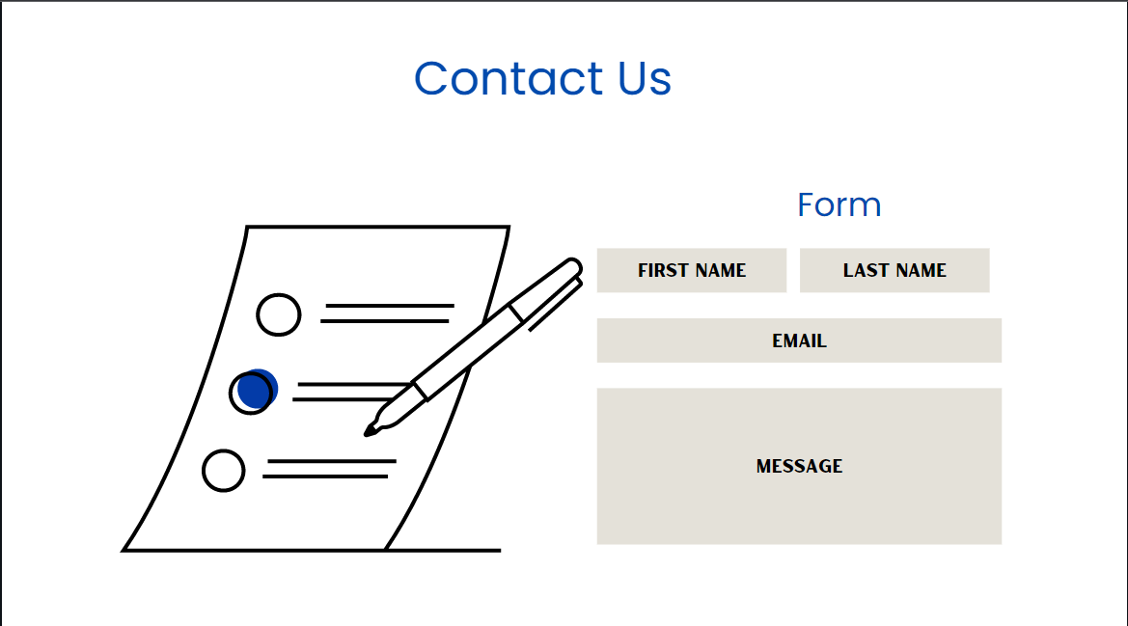

#### FAQ MODULE

Lastly, we will have a module for the frequently asked questions. This will help with customer interactions in the website, i.e., before a customer can raise an issue, they can check whether their problem has already been handled before.

